Pesticides and food chains

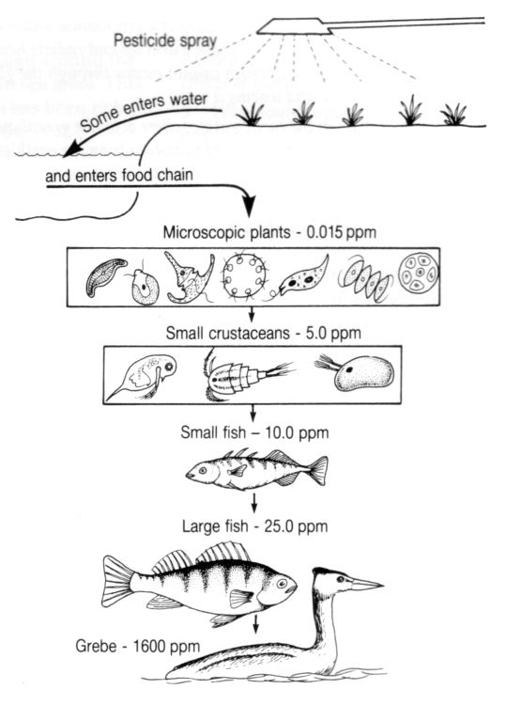
The picture shows what can happen if a poisonous chemical pesticide is sprayed near some water.

The numbers show how much pesticide is in the living things.

- Which living thing has most pesticide in it?

- What is the relationship between position in the food chain and amount of pesticide?

- Calculate by how much the pesticide has increased at each link in the chain.

- Choose a pencil crayon colour. Use it to shade the
microscopic plants in very
lightly.

- Use the same colour to shade in each of the other sets of living things.
Make the colour a little bit darker every time you go down the food chain.

The Grebe should end up being shaded in the darkest. Stick the picture in.

- What does the colour represent?

- Which group of organisms have most pesticide in their bodies and so are most affected by pesticide pollution?

- Now use the same colour to shade in these living things.

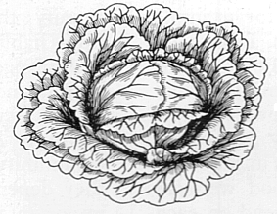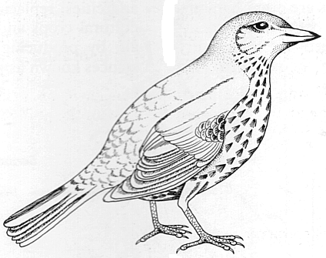Try to work out which should have the lightest shading and which should have the darkest.



